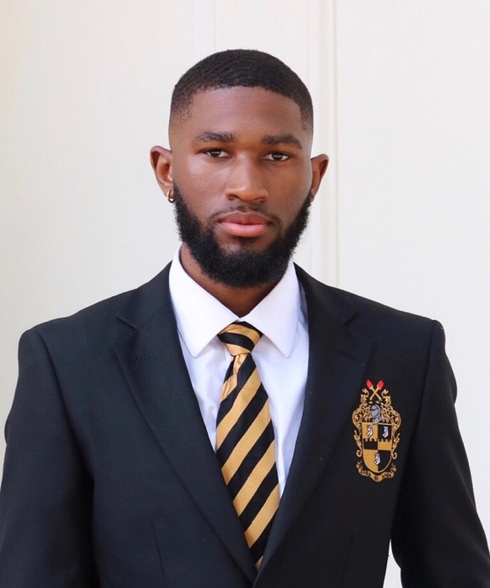
Brindon Reed is a senior at SHSU, majoring in Health Care Administrations with a concentration in Biology and a minor in Psychology. He was born in Houston, Texas to a strong willed, single mother of two girls. His upbringing upholds and sustains an unwavering devout to God and the church. Mr. Reed’s saturated involvement in his community, through outreach and volunteer programs like the Boys & Girls Club, The Houston Food Bank, Free Indeed Church Int., & Harvey Hurricane Relief program to name a few, has allowed him to position himself as a leader and mentor to many young men who are wayward and need a voice of encouragement to catapult them into their goals. His accomplishments include a spot on the Dean’s and President’s List several times since he has enrolled at SHSU, organizing a charity auction for Hurricane Harvey Relief, in which a revenue of $3000 was earned in the Fall of 2018 and Orchestrated a blindspot exhibit for the Diversity Leadership Conference at Sam Houston State University. Brindon’s desire to not only excel, but to most importantly impact, is the interval ingredient to his success.

